Prerequisite

1. Install Code Blocker for compile the script, steps are below:

Click on the link to go that page (click Ctrl & the link) <https://www.codeblocks.org/>

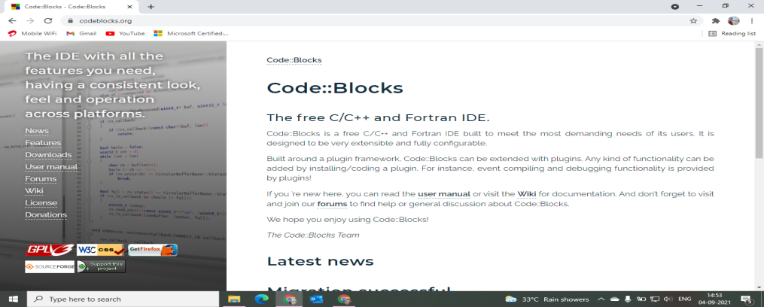

a) Select Download and then click “Download the binary release”

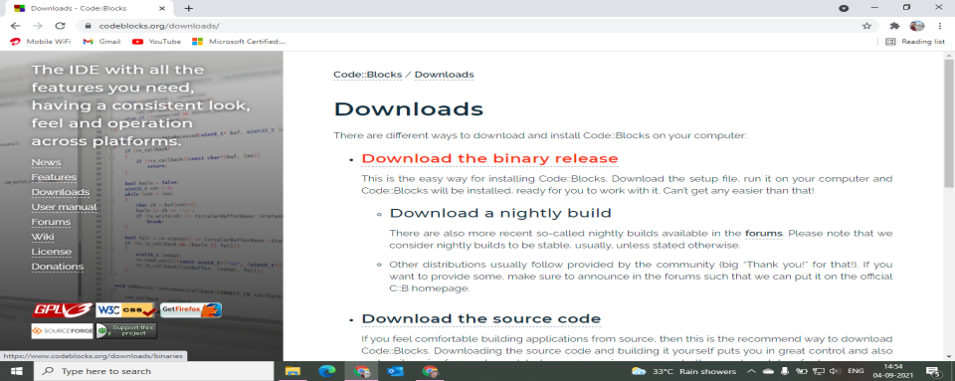

b) Then scroll down & select “FossHUB” next to “codeblocks-20.03mingw-setup.exe”

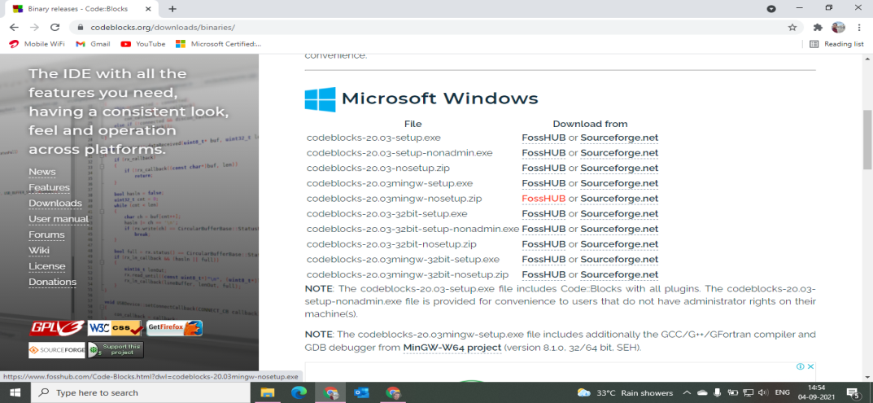

c) After download install completely.

2) Set Compiler path to run script in CMD. Follow the steps below:

a) Open: This pc\ Local Disk-C\ Program Files

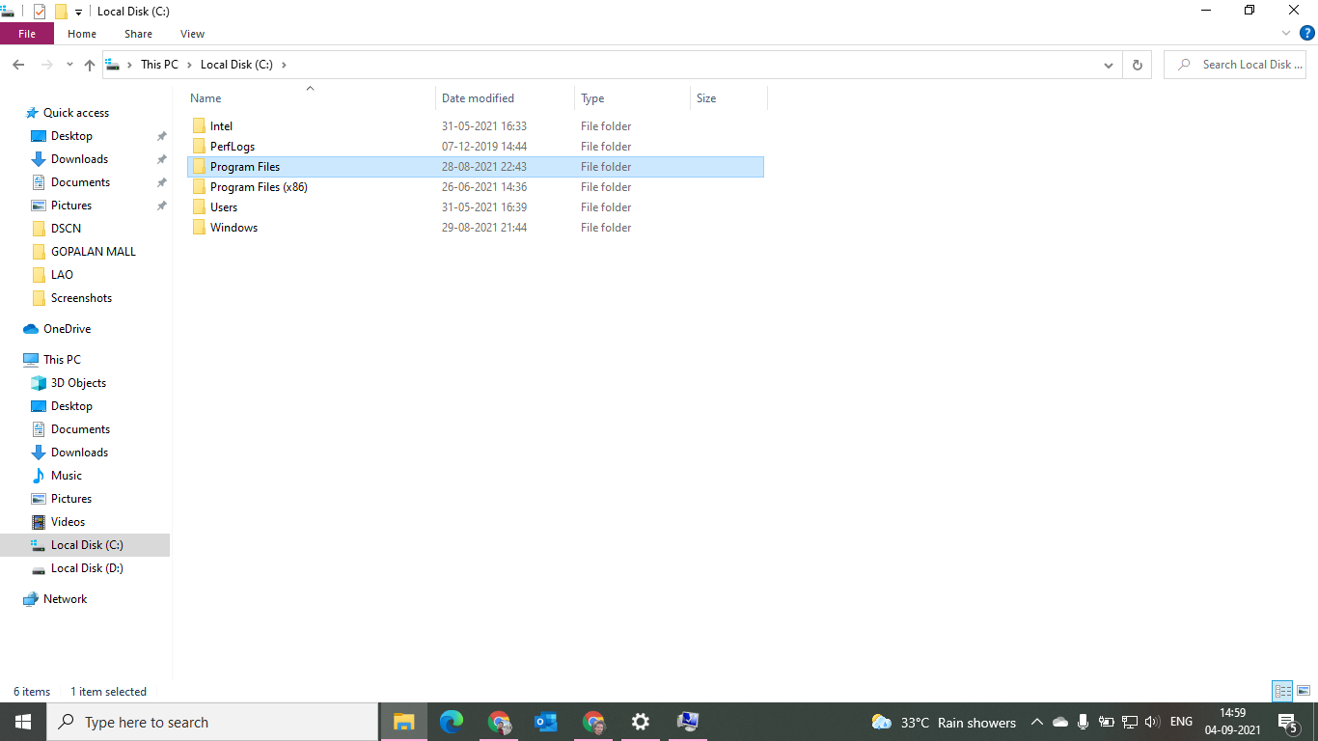

Inside that select CodeBlocks:

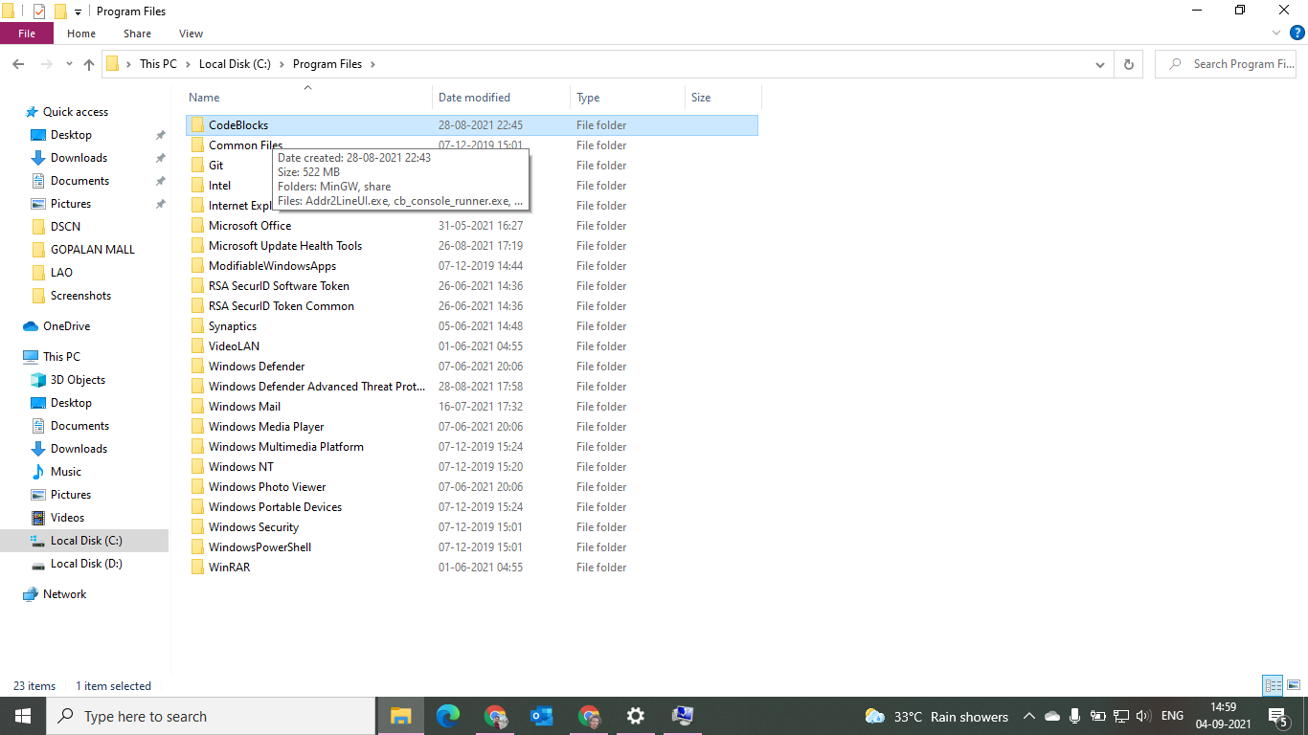

Inside that select “MinGW”:

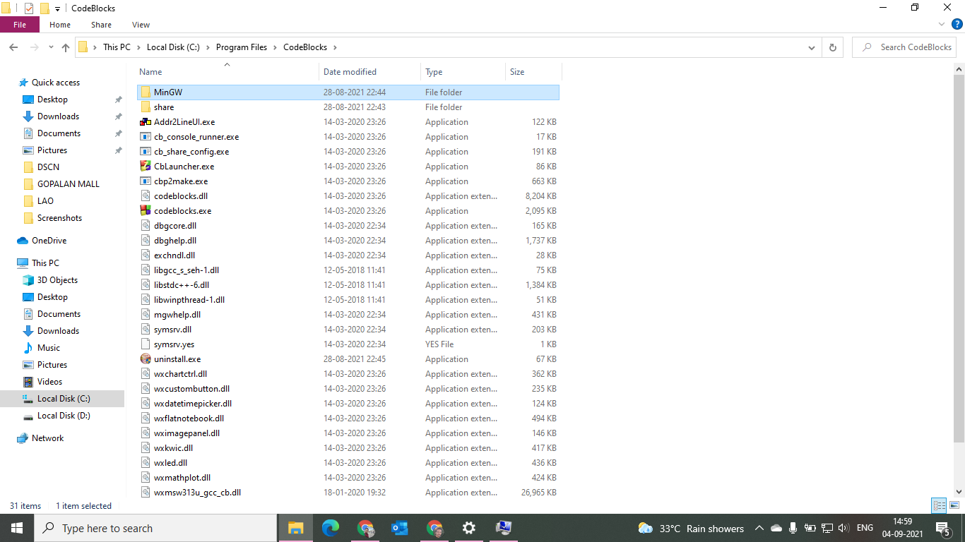

Inside that select “bin”:

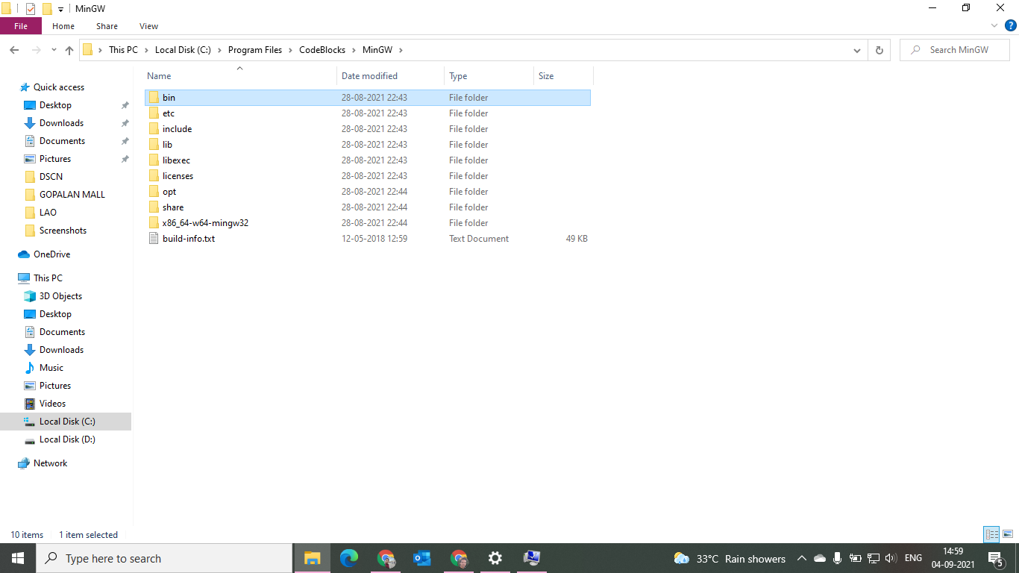

b) Select the path and copy

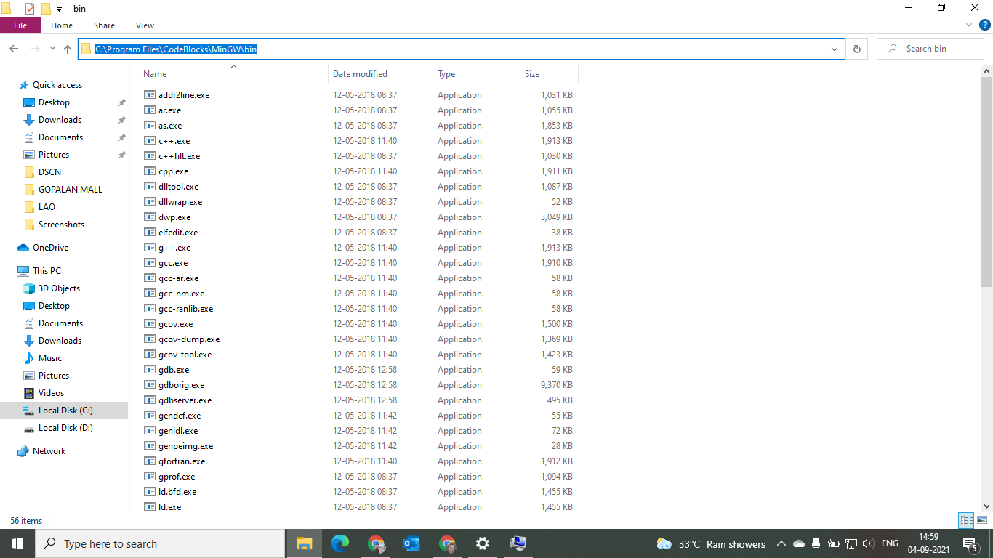

c) Right click on “This Pc”, select “Properties”

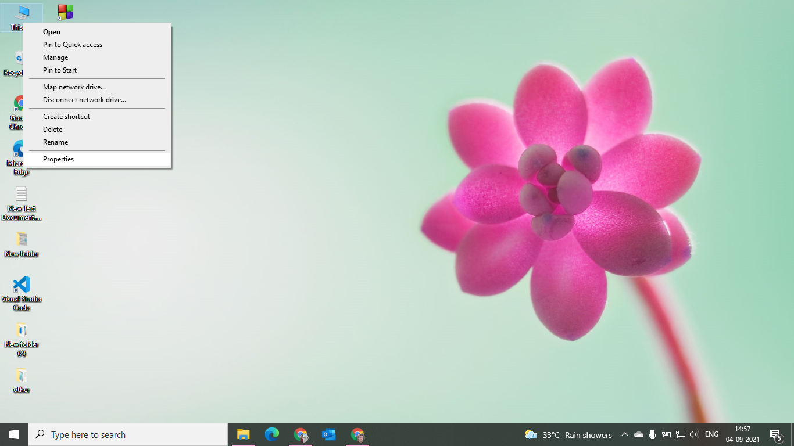

d) Then select “Advanced system settings” then “Environment variable” then in system variables; Double click on “Path”

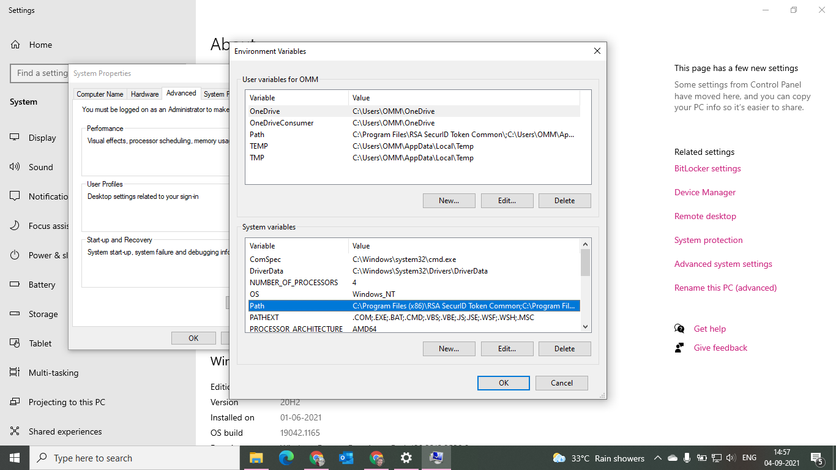

e) Click on “New” paste the paste path copied of “bin” .

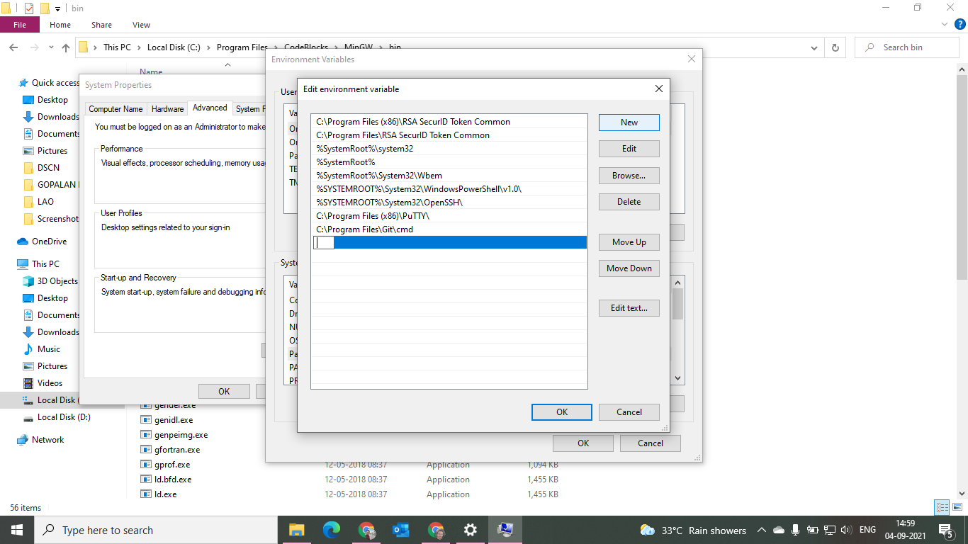

f) After path pasted click OK .

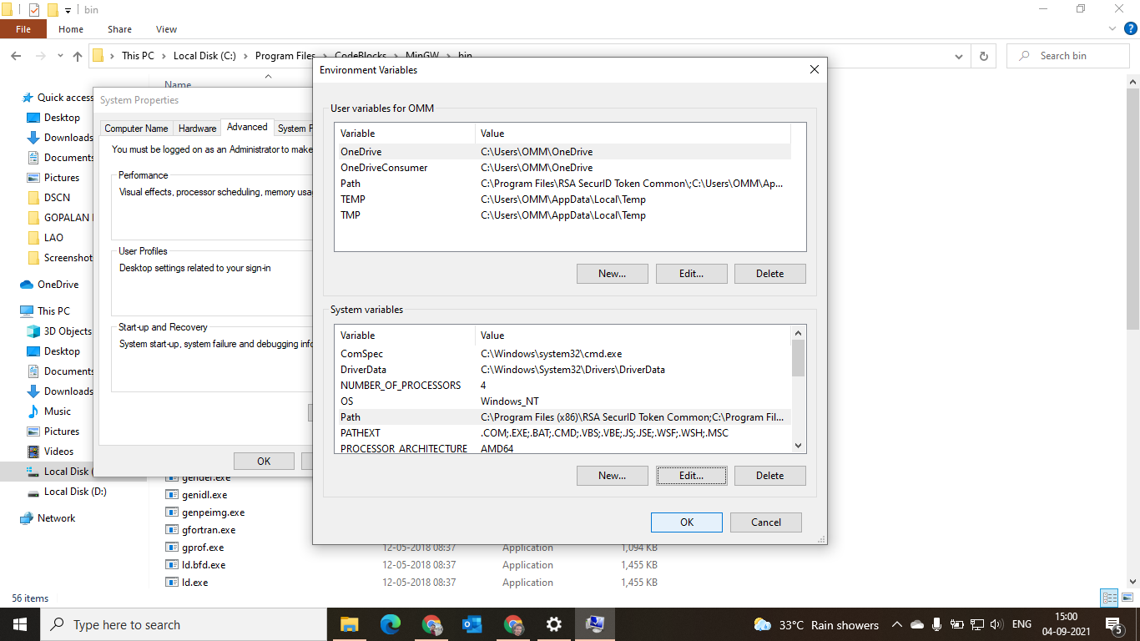

3) In search type CMD and open

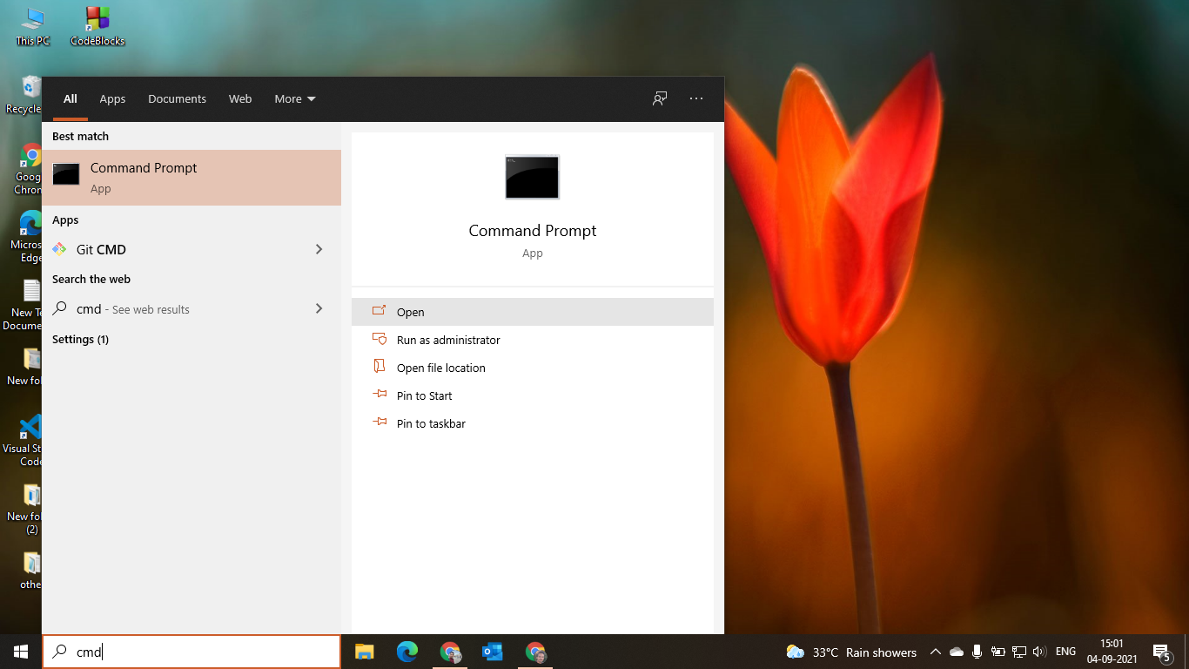

4) Type “gcc –version” in cmd and “cd desktop” 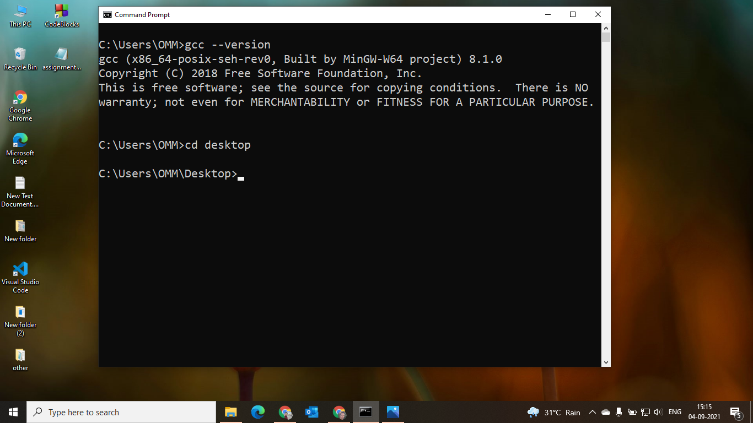

5) Copy our script notepad and execute file to desktop and run “assignment3” in cmd to see output of our script.

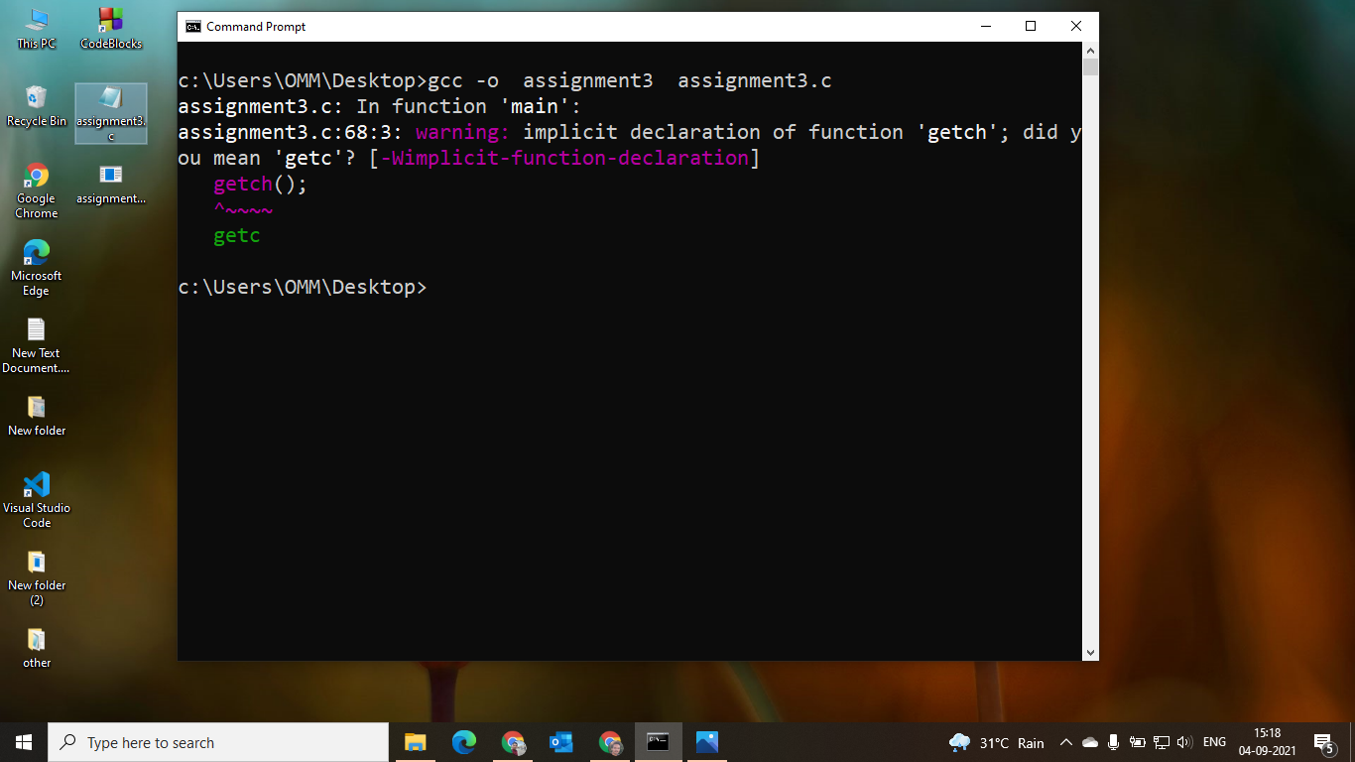

6) Now follow User Manual for further progress.

Thank You